**Project Design Phase-II**

**Data Flow Diagram & User Stories**

|  |  |
| --- | --- |
| Date | 26 June 2025 |
| Team ID | LTVIP2025TMID30678 |
| Project Name | To Supply Leftover Food To Poor |
| College Name | Aditya collage of Engineering and Technology |
| Team members | 1)Sadi ramana (Leader) – 22MH1A04D6   * [Ramanarebel69@gmail.com](mailto:Ramanarebel69@gmail.com)   2)Sravani kasireddy (Documentation developer and opearator ) - 23MHA0412   * [Sravanikasireddy850@gmail.com](mailto:Sravanikasireddy850@gmail.com) |

**Flow Chart:**

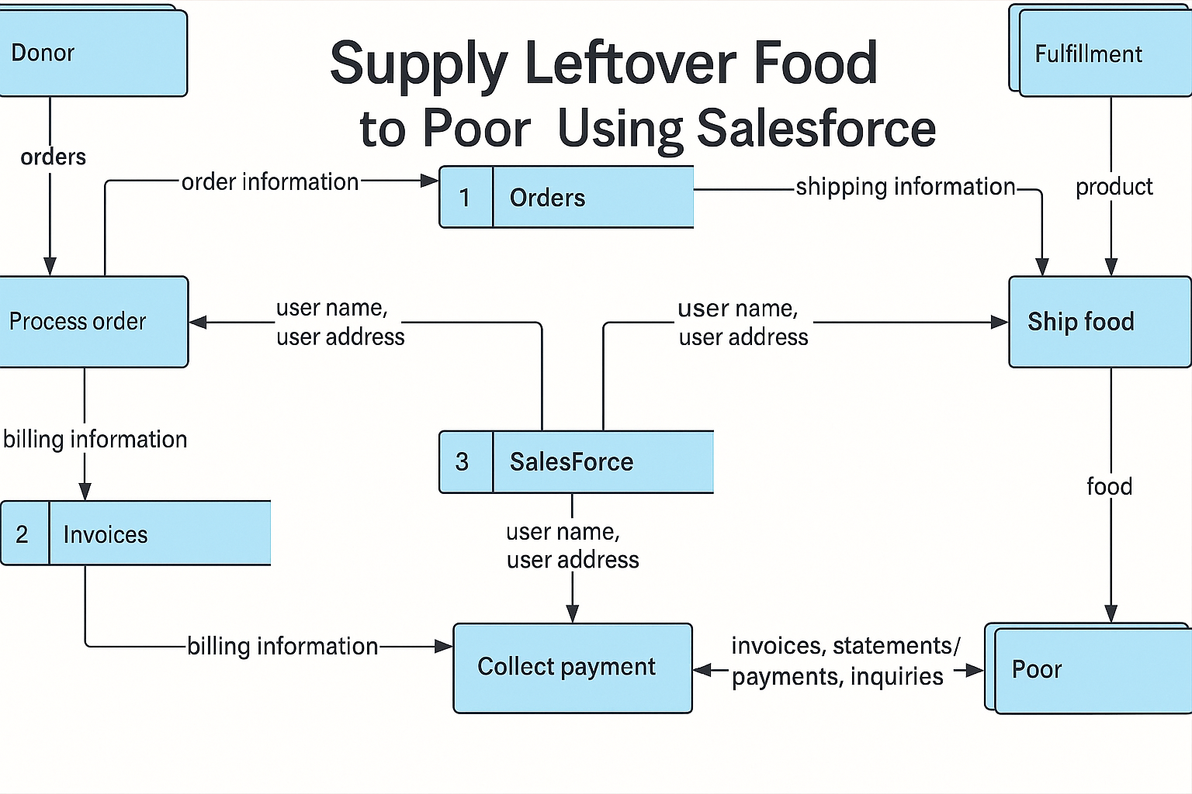

### 

### **🗂️ Product Backlog Table – Supply Leftover Food to Poor Using Salesforce**

|  |  |  |  |  |  |  |
| --- | --- | --- | --- | --- | --- | --- |
| **User type** | **Functional requirement (epic)** | **User story number** | **User story / task** | **Acceptance criteria** | **Priority** | **Release (Sprint)** |
| Customer (mobile user) | Registration | USN - 1 | As a user i can register by entering email,password,and confirming password | I can access my account/dashboard | High | Sprint - 1 |
|  | Registration | USN - 2 | As a user i will receive confirmation email once i register | I receive email and can confirm it | High | Sprint - 1 |
|  | Registration | USN - 3 | As a user i can register via facebook | I can log in using facebook and access the dashboard | Low | Sprint - 2 |
|  | Registration | USN - 4 | As a user i can register via email | I can log in using email and access the dashboard | Medium | Sprint - 1 |
|  | Login | USN - 5 | As a user, I can log into the application using email and password | Successful login redirects me to dashboard | High | Sprint - 1 |
|  | Dashboard | USN - 6 | As a user, I can view nearby leftover food donations available | List of donations is shown based on location | High | Sprint - 2 |
|  | Request Food | USN - 7 | As a user, I can request leftover food from a nearby donor | Request is submitted and visible to the donor | High | Sprint - 2 |
| Customer (Web user) | Registration | USN - 8 | As a user, I can register and log in through the web platform | Account creation and login functional via browser | Medium | Sprint - 2 |
|  | View Donations | USN - 9 | As a user, I can view all available donations | Table/grid of donations visible with filter/search options | High | Sprint - 2 |
| Customer Care Executive | Verify Requests | USN-10 | As a CCE, I can verify incoming food requests from users | Each request is marked as verified/approved/rejected | High | Sprint - 3 |
|  | Manage Complaints | USN-11 | As a CCE, I can manage and resolve complaints from users | Complaint is tracked with resolution status | Medium | Sprint - 3 |
| Administrator | User Management | USN-12 | As an admin, I can view and manage all users (customers, CCEs) | Admin panel lists all users with role-specific controls | High | Sprint - 3 |
|  | Analytics Dashboard | USN-13 | As an admin, I can view analytics on donations, users, and fulfillment | Graphical reports and charts visible | Medium | Sprint - 4 |